# Final Project

## Female Baby Names in New York City, 2011

Data.gov provides interesting demographics data sets, including the most popular baby names in New York City from 2011 to 2014. After filtering the dataset down to female names for the year 2011, roughly 600 records were inserted into the MySQL database and visualized using HighCharts and d3.js.

Using HighCharts, we can visualize a pie chart of each name, using the count of newborns given that name to determine the size of each slice of the pie. A screenshot of FemaleBabyNames.php illustrates this visualization, and we can clearly see that Isabella was the most popular name for baby girls born in 2011, accounting for nearly 2% of all newborns in the dataset.

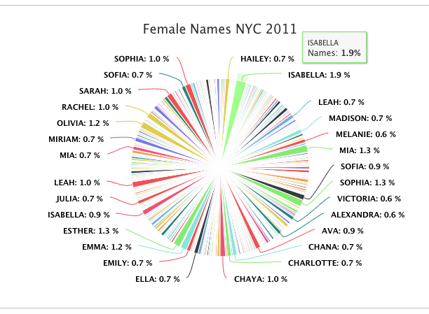

Using d3, we are able to use the pack layout to generate a bubble chart, where the size and color of the bubble correlates with the popularity of the name. We observe that Isabella, Sophia, Emma, Esther and Olivia are among the most popular names for newborn girls in 2011 in NYC. This visualization is located at FemaleBabyNames2.php

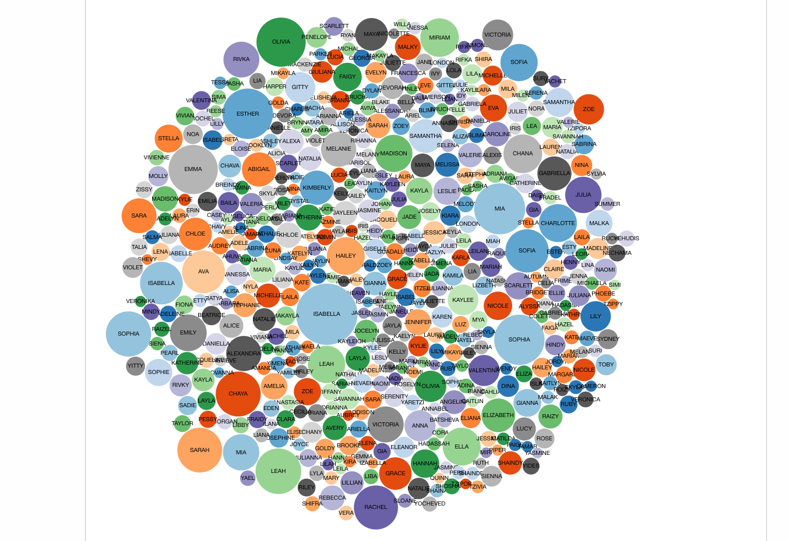

## Commercial Waterway Commerce Tonnage

The Department of Defense provides public data regarding the tonnage of commerce cargo shipped via commercial waterways. Ranging from 1975 to 2016, this data sheds light on the level of importing and exporting taking place on our waterways.

Using d3, we are able to visualize the total trade happening via our waterways, and we can see a steady upward trend in trade, reflecting the increasing globalization that is fundamental to the US economy’s health. This visualization is located at TotalTonnage.php

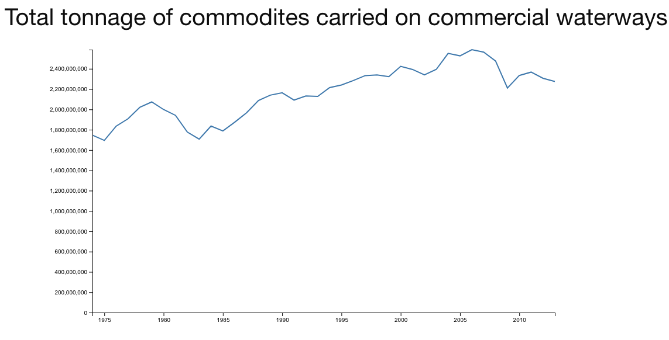

Using HighCharts, we are able to visualize the split between domestic and foreign commerce, best displayed as a stacked area chart. The sum of domestic and foreign commerce for a particular year adds up to the value depicted in the d3 total line chart. This chart can be found on TonnageByGroup.php

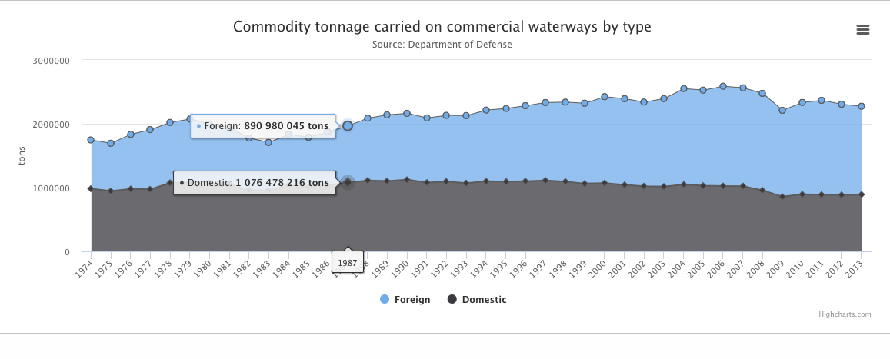

## US Renewable Energy Technical Potential

The US Department of Energy published a report on the alternative energy generation potential of each state in the US, outlining how much of each alternative energy a particular state can expect to generate given the existing infrastructure in that state.

Using d3, we can generate a column chart demonstrating the potential hydroelectric gigawatt hours each state can expect to generate.

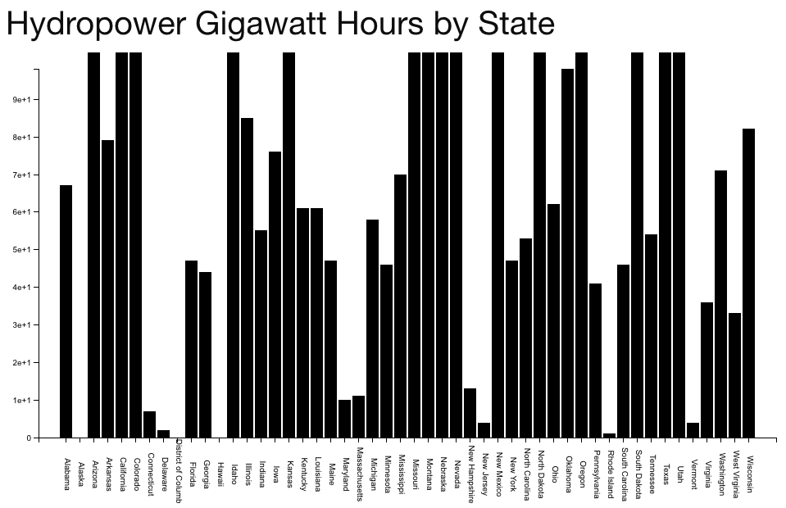

Whereas states like Delaware and Rhode Island demonstrate little potential to generate significant hydroelectric power, larger population centers like California appear to be well-poised to contribute hydroelectric energy to the national power grid. This visualization can be found on HydropowerGWhPotential.php.

Using Highcharts, we are able to visualize a Honeycomb tile map with a geographically-accurate layout to gain a more intuitive sense of which states are projected to generate the most photovoltaic (solar) energy in terms of gigawatt hours. We can view this visualization at PotentialSolar.php

